AVERAGING & EXPONENTIAL SMOOTHING FORECASTING METHODS

Introduction

This section presents two simple time series forecasting approaches: averaging methods and exponential smoothing methods. Two versions of each approach are presented here: simple moving averages and weighted moving averages for the averaging methods and simple exponential smoothing and adjusted exponential smoothing for the exponential smoothing methods. The section concludes with a number of simple tests that can be used to measure the accuracy of each forecasting model.

When you have worked through this section, you should be able to:

- Formulate simple and weighted moving average models to produce time series forecasts.
- Formulate simple exponential smoothing models to produce time series forecasts.
- Adjust the forecasts produced by the simple exponential smoothing method to improve the accuracy of the forecasts.
- Produce a single measure of a model’s usefulness or reliability and compare the accuracy of different forecasting models.
- Appreciate the advantages and limitations of averaging and exponential smoothing forecasting methods and of the most commonly used tests for measuring forecast accuracy.

Averaging methods

The main characteristic of the method of moving averages is that it generates a forecast for a particular time period by averaging the observed data values (that is the actual values of the dependent variable) for the most recent n time periods. As each time period evolves, the observed data value for the new period is added to the average and the observed data value for the oldest period is subtracted from the average giving a new average value.

Two versions of this method are presented here: simple moving averages and weighted moving averages.

Simple Moving Averages (SMA)

The method of simple moving averages smoothes out random fluctuations of data. This method is best used for short-term forecasts in the absence of seasonal or cyclical variations. On the other hand, this method is not particularly good in situations where the series has a trend.

SMA generates a forecast value for the next immediate period by averaging the n most recent observed data values (denoted by Y_{t}). This can be shown as follows:

Σ (most recent n Y_{t} values)
SMA = ----------------------------------- (5.1)
n

where:

Y_{t} is the actual value of the dependent variable for period t
n is the number of actual values included in the average

Consider the following simple example showing the volume of sales of a product over a time period of six weeks.

Table 5.1 Time series data

Week Sales (Y_{t})
1 130
2 70
3 140
4 150
5 90
6 180

We can formulate a 3-point SMA model by averaging the first three actual values and using that average as the forecast for the next time period (week 4). In other words, the forecast for week 4 will be the average actual volume of sales from the previous three weeks. Then a forecast for week 5 is produced simply by working out the average actual volume of sales for weeks 2, 3, and 4. The SMA forecasts are shown in
table 5.2.

Table 5.2 SMA forecasts

Week Sales (Y_{t}) Forecast (F_{t})
1 130 -
2 70 -
3 140 -
4 150 113.34
5 90 120.00
6 180 126.67
7 140.00

Note that in the above table F_{t} has been used to denote the forecast value for period t. The forecast for period 4 will therefore be 113.34 and the forecast for period 7 will be 140. The difference between a Y_{t} value and an F_{t} value is that the first refers to data that has occurred, whereas the second indicates a predicted result. This is the notation that will be used from now on to show the distinction between an actual data value and a predicted one.

In a series of n observations the method of moving averages will not be able to generate a forecast for more than one period ahead. One way to produce forecasts for more than one period ahead would be using the technique of trend projection. To do this, we simply need to calculate the increment of the projection, given in relation 5.2, and add this to the last forecast value. This will produce a linear projection.

Last F_{t} - First F_{t}
Increment = ---------------------- (5.2)
n-1

where :

Last F_{t} is the last forecast value produced by the SMA model
First F_{t} is the first forecast value produced by the SMA model
n is the number of forecast values produced by the SMA model

Application of relation (5.2) will produce the following result:

Increment = (140-113.34)/3 = 8.89

The forecast for week 8 will therefore be as follows:

F₈ = 140.00 + 8.89 = 148.89

Similarly, the forecast for week 9 will be as follows:

F₉ = 148.89 + 8.89 = 157.78

and so on.

Graph 5.1 shows the actual against the predicted volumes of sales produced by the above SMA model (notice the linear pattern in the forecast values produced by the trend projection technique).

Graph 5.1 Actual vs predicted sales (SMA model)
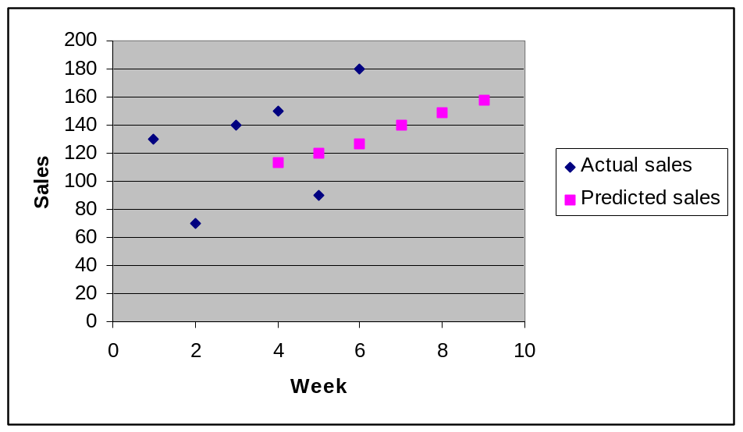
Finding the right number of observed data values to be included in the average (that is determining the order of the moving average) is a matter of judgement and trial-and-error experimentation. The smaller the number the more weight is given to recent periods. On the other hand, the greater the number the less weight is given to recent periods.

A moving average model with a large number of values included in the average will also be less sensitive to random variations and respond more slowly to the variations in the series. On the other hand, a moving average model with a small number of values included in the average will be more sensitive to these variations and will produce more oscillations which might be misleading.

The choice of the number of values to be included in the average is also affected by other factors, such as the type of the data itself. If, for example, the data has been collected on a quarterly basis, the forecaster could start his or her experimentation by formulating a four-point SMA model.

Moving averages are frequently used with quarterly or monthly data to help smooth the components within the series. For quarterly data, a four-point moving average yields an average of the four quarters and, for monthly data, a 12-point moving average eliminates or averages out seasonal effects. The larger the order of the moving average the greater the smoothing effect.

In any case, the forecaster should experiment with different simple moving average models until one which seems to be producing satisfactory results has been found.

The advantages of the method of simple moving averages are as follows:

- It is easy to learn and apply.
- It has a relatively low computational cost.
- It can produce accurate forecasts.
- It produces forecasts quickly.

The disadvantages of the method of simple moving averages are as follows:

- It fails to produce accurate forecasts if the data has cyclical or seasonal variations.
- It does not handle trend very well.
- It gives an equal weight to every time period selected and this makes the forecasts lag behind the underlying trend.

Weighted Moving Averages (WMA)

The method of weighted moving averages is another averaging time series forecasting method that smoothes out random fluctuations of data. This method is also best used for short-term forecasts in the absence of seasonal or cyclical variations.

Like SMA, WMA also generates a forecast value for the next time period by averaging the observed data values (Y_{t}) for the most recent n time periods. The only difference between SMA and WMA is that the latter uses weights in order to vary the effect of past data. This method assigns weights to each observed data point and works out a weighted mean as the forecast value for the next time period. This can be shown as follows:

WMA = Σ(weight x Y_{t} value for most recent n periods) (5.3)
where:

Y_{t} is the actual value of the dependent variable for period t
n is the number of time periods included in the average

As weights are used to vary the effect of past data, based on the fact that more recent data is more important, the weights should go up and always add up to 1. A possible set of weights could then be 0.17, 0.33, 0.50. These weights have been used to produce forecasts for the data set used in the previous section.

Table 5.3 WMA forecasts

Week Sales (Y_{t}) Forecast (F_{t})
1 130 -
2 70 -
3 140 -
4 150 115.20
5 90 133.10
6 180 118.30
7 145.20

The forecast values for periods 4, 5, 6 and 7 have been produced as follows:

F₄ = (130x0.17)+(70x0.33)+(140x0.50) = 115.20

F₅ = (70x0.17)+(140x0.33)+(150x0.50) = 133.10

F₆ = (140x0.17)+(150x0.33)+(90x0.50) = 118.30

F₇ = (150x0.17)+(90x0.33)+(180x0.50) = 145.20

The trend projection technique could then be used to produce a forecast for more periods ahead exactly in the same way as before:

Increment = (145.20-115.20)/3 = 10

F₈ = 145.20 + 10 = 155.20

F₉ = 155.20 + 10 = 165.20

and so on.

Graph 5.2 shows the actual against the predicted volumes of sales produced by the above WMA model (again notice the linear pattern in the forecast values produced by the trend projection technique).
Graph 5.2 Actual vs predicted sales (WMA model)
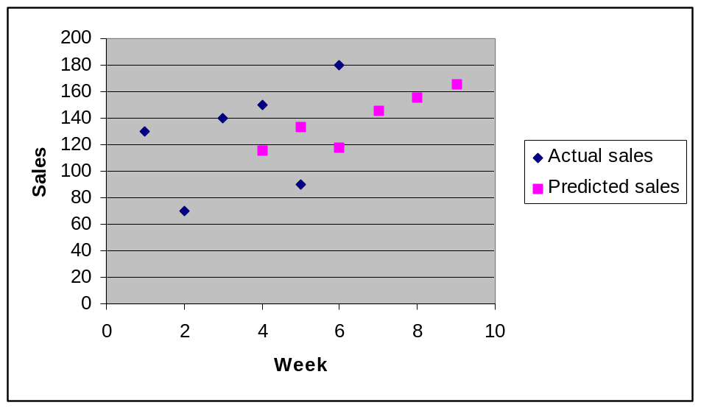
There is an almost infinite number of possible weighting schemes. Finding the right weights to be included in a WMA model, like finding the right number of time periods for a SMA model, is a matter of judgement and trial-and-error experimentation.

As this method uses weights, it is more suitable in situations where the series has a trend. The stronger the trend the more heavily recent data needs to be weighted. The forecaster should remember, however, that if recent data is weighted too heavily, the resulting forecast might be an overreaction to what is simply a random fluctuation. On the other hand, weighting too lightly might result in an underreaction (lagging) to an actual change in the pattern.

Like the case of simple moving averages, the forecaster should experiment with different sets of weights until a model which seems to be producing satisfactory results has been found.

The advantages of the method of weighted moving averages are as follows:

- It is easy to learn and apply.
- It has a relatively low computational cost.
- It can produce accurate forecasts.
- It produces forecasts quickly.
- It responds more rapidly to changes in the pattern.
- It can produce more accurate forecasts than a SMA model if applied to a trended series.

The disadvantages of the method of weighted moving averages are as follows:

- It fails to produce accurate forecasts if the data has cyclical or seasonal variations.
- The actual data values have to be multiplied by some weights and this makes calculations more difficult.

Exponential Smoothing methods

Averaging forecasting methods generally have one serious operational shortcoming. This is that if n data points are to be included in the average, then n-1 pieces of past data must be brought forward, in order to be combined with the current (the n^{th}) observation. That past data must be stored in some way in order to produce the forecast.

The problem of storing all the data required becomes serious when a large number of forecasts are required. If, for example, an organisation is using an 8-point simple moving average model to forecast the demand for 5,000 small parts, then for each part 7 pieces of data must be stored for each forecast (assuming that the current (8th) data value is available and does not need to be stored).

If 7 pieces of data are required for each forecast, then the forecaster will need 35,000 pieces of data (7x5,000) to be stored, in order to compute a single moving average forecast for every part. In a case like this, storage requirements as well as computing time should be important factors in designing the forecasting system.

Exponential smoothing methods are averaging methods (in fact, exponential smoothing is a short name for an exponentially weighted moving average) that require only three pieces of data: the forecast for the most recent time period (F_{t}), the actual value for that time period (Y_{t}) and the value of the smoothing constant (denoted by α).

In the previous example, if the forecaster uses an exponential smoothing model to forecast the demand for the 5,000 parts, then 5,001 pieces of data would have to be stored (the 5,000 most recent forecast values and the value of the smoothing constant), as opposed to the previously computed 35,000 pieces of data needed to implement an 8-point moving average.

Simple Exponential Smoothing

Simple exponential smoothing (usually referred to as exponential smoothing) is a time series forecasting method that smoothes out random fluctuations of data. It is best used for short-term forecasts in the absence of seasonal or cyclical variations. Similarly, the method does not work very well if the series has a trend.

Exponential smoothing weights past data with weights that decrease exponentially with time, thus adjusting for previous inaccuracies in forecasts. To do that, the method uses a weighting factor (known as the smoothing constant), which reflects the weight given to the most recent data values.

Exponential smoothing produces forecasts by using any of the following relations:

F_{t+1} = α Y_{t} + (1-α) F_{t} (5.4)

F_{t+1} = F_{t} + α (Y_{t} - F_{t}) (5.5)

where:

F_{t+1} is the forecast value of the dependant variable for period t+1
F_{t} is the forecast value of the dependant variable for period t
Y_{t} is the actual value of the dependant variable for period t
α is the value of the smoothing constant

As it can be seen from relation (5.5), exponential smoothing is simply the old forecast (F_{t}) adjusted by α times the error (Y_{t} - F_{t}) in the old forecast.

Consider the sales example used earlier on.

Table 5.4 Time series data

Week Sales (Y_{t})
1 130
2 70
3 140
4 150
5 90
6 180

Let's use an exponential smoothing model with α=0.3 and use it to predict the volume of sales for the above time periods. The choice of the value of α will be discussed later on. The results are shown in table 5.5.

Table 5.5 Exponential smoothing forecasts

Week Sales (Y_{t}) Forecast (F_{t})
1 130 130.00
2 70 130.00
3 140 112.00
4 150 120.40
5 90 129.28
6 180 117.50
7 136.25

Note that in order to produce a forecast for period t+1, we need the actual value for period t, the forecast value for period t, and the value of the smoothing constant α. Since the forecast value for period 1 does not exist, we should guess it. A reasonable guess would be to take the forecast value for period 1 to be the same as the actual value for that period (i.e. assume that we have a perfect forecast).

Application of relation 5.5 will then produce the following forecasts:

F₂ = 130 + 0.3 (130-130) =130.00

F₃ = 130 + 0.3 (70-130) = 112.00

F₄ = 112 + 0.3 (140-112) = 120.40
..

F₇ = 117.50 + 0.3 (180 -117.50) = 136.25

Like the methods of moving averages, exponential smoothing can only produce a forecast for one period ahead. The trend projection technique could then be used to generate forecasts for more periods ahead.

Increment = (136.25-130)/6 = 1.04

F₈ = 136.25 + 1.04 = 137.29

F₉ = 137.29 + 1.04 = 138.33

and so on.

Graph 5.3 shows the actual against the predicted volumes of sales produced by the above exponential smoothing model (including the trend projection technique).

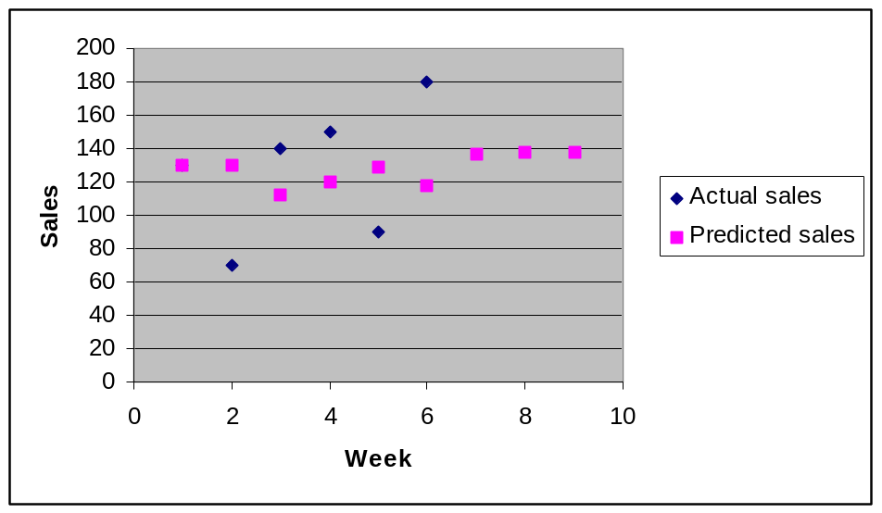Graph 5.3 Actual vs predicted sales (ES model)

The value of the smoothing constant α lies between 0 and 1. Its value determines the degree of smoothing and how responsive the model is to fluctuations in the data. The larger the value given to α the more strongly the model reacts to the most recent data.

When the value of α is close to 1, the new forecast will include a substantial adjustment for any error that occurred in the preceding forecast. On the other hand, when the value of α is close to 0, the new forecast will be very similar to the old one.

If a time series is fluctuating erratically, as a result of random variability, the forecaster should choose a small value of α. On the other hand, the forecaster should choose a larger value of α, if the series is more stable and shows little random fluctuation.

If it is desired that predictions be stable and random variations smoothed, then a small value of α is required. If a rapid response to a real change in the pattern of observations is desired, then a larger value of α is appropriate.

The method of moving averages fails to produce accurate forecasts if the series has a significant trend or a seasonal variation. There are other versions of exponential smoothing which can handle strong trend patterns (Holt's method) or strong trend and seasonal variation patterns (Winter's method). These methods are not covered here but they are discussed in a number of forecasting textbooks.

The advantages of exponential smoothing are as follows:

- It is easy to learn and apply.
- It has a relatively low computational cost.
- It can produce accurate forecasts.
- It can produce forecasts quickly.
- It gives greater weight to more recent observations.
- It requires a significantly smaller amount of data to be stored compared to the methods of moving averages.
- It considers the data as a whole and does not require cut-off points as is the case with the methods of moving averages.
- It can alter the value of the smoothing constant to fit the model properly in any different circumstances.

The disadvantages of exponential smoothing are as follows:

- It has a tendency to produce forecasts that lag behind the actual trend.
- It fails to produce accurate forecasts if the data has cyclical or seasonal variations.
- It does not handle trend very well.
- The forecasts generated by an exponential smoothing model are sensitive to the specification of the smoothing constant.

Adjusted Exponential Smoothing

One of the disadvantages of exponential smoothing is that it tends to produce forecasts that lag behind the actual trend. The adjusted exponential smoothing method can adjust exponentially smoothed forecasts to correct for a trend lag. Like simple exponential smoothing, adjusted exponential smoothing is also best used for short-term forecasts in the absence of seasonal or cyclical variations.

In order to use the adjusted exponential smoothing method the forecaster should have first produced a forecast for a particular time period. An adjusted forecast is then produced for that time period by the following relation:

adj. F_{t+1} = F_{t+1} + [(1-β)/β] T_{t+1} (5.6)

where:

adj. F_{t+1} is the adjusted forecast value for period t+1
F_{t+1} is the unadjusted forecast value for period t+1
T_{t+1} is the trend factor for period t+1
β is the value of the smoothing constant

It can be seen that the above formula uses a smoothing constant β and a trend factor T_{t+1}. The smoothing constant β has exactly the same meaning as the smoothing constant α used in the previous version of exponential smoothing. It is a weighting factor reflecting the weight given to the most recent data and is used by the formula in order to smooth the trend and prevent erratic responses to random fluctuations.

T_{t+1} is an exponentially smoothed trend factor that is used in order to convert the initial unadjusted exponential smoothing forecast to an adjusted exponential smoothing forecast. The trend factor for period t+1 is given by the following formula:

T_{t+1} = β (F_{t+1}- F_{t}) + (1-β) T_{t} (5.7)

where:

T_{t+1} is the trend factor for period t+1
T_{t} is the trend factor for period t
F_{t+1} is the unadjusted forecast value for period t+1
F_{t} is the unadjusted forecast value for period t
β is the value of the smoothing constant

An adjusted exponential smoothing model with a β value of 0.3 has been used to adjust the forecasts produced by the exponential smoothing model developed in the previous section. The choice of the value of β will be discussed later on. The results are shown in table 5.6.

Table 5.6 Adjusted exponential smoothing forecasts

(t) (Y_{t}) (F_{t}) (T_{t}) (adj. F_{t})
1 130 130.00 0.00 -
2 70 130.00 0.00 130.00
3 140 112.00 -5.40 99.40
4 150 120.40 -1.26 117.46
5 90 129.28 1.78 133.44
6 180 117.50 -2.29 112.16
7 136.25 4.02 145.64

Note that the trend factor for period 1 is always set to zero. The trend factor values for the other time periods have been computed as follows:

T₂ = 0.3 (130-130) + (1-0.3) 0.00 = 0.00

T₃ = 0.3 (112-130) + (1-0.3) 0.00 = -5.40

..

T₇ = 0.3 (136.25-117.50) + (1-0.3) (-2.29) = 4.02
The forecast values produced by the exponential smoothing model in the previous section can now be adjusted using relation (5.7). The calculations are as follows:

adj.F₂ = 130 + 2.33 (0.00) = 130.00

adj.F₃ = 112 + 2.33 (-5.40) = 99.40

.. ..

adj.F₇ = 136.25 + 2.33 (4.02) = 145.64

The trend projection technique could then be used to generate a forecast for more periods ahead.

Increment = (145.64-130)/5 = 3.13

adj. F₈ = 145.64 + 3.13 = 148.77

adj. F₉ = 148.77 + 3.13 = 151.90

and so on.

Graph 5.4 shows the adjusted forecasts produced by the exponential smoothing model in the previous section against the actual volume of sales.

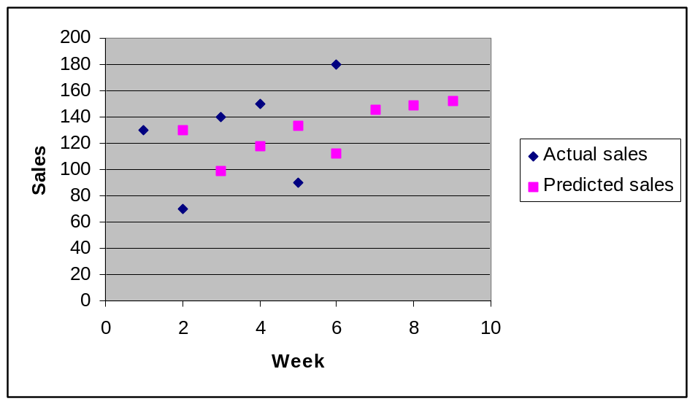Graph 5.4 Actual vs predicted sales (AES model)

Like the value of α in an exponential smoothing model the value of β in an adjusted exponential smoothing model also lies between 0 and 1. If it is close to 0, then only a small adjustment for error in the previous forecast is made. If it is close to 1, then a substantial adjustment for error in the previous forecast is made.

The choice of the value of β is also a subjective decision that the forecaster has to make and it is again based on trial-and-error experimentation.

The advantages of adjusted exponential smoothing are as follows:

- It is easy to learn and apply.
- It has a relatively low computational cost.
- It can produce accurate forecasts.
- It can produce forecasts quickly.
- It gives greater weight to more recent observations.
- It requires a significantly smaller amount of data to be stored compared to the methods of moving averages.
- It considers the data as a whole and does not require cut-off points as is the case with the methods of moving averages.
- It can alter the value of the smoothing constant to fit the model properly in any different circumstances.
- It does not lag behind the actual trend and it can therefore produce more accurate forecasts.

The disadvantages of adjusted exponential smoothing are as follows:

- It fails to produce accurate forecasts if the data has cyclical or seasonal variations.
- It does not handle trend very well.
- The forecasts generated by an adjusted exponential smoothing model are sensitive to the specification of the smoothing constant.
- It involves more complex calculations as two formulae have to be used.

Measuring forecast accuracy

Part of the decision to use a particular forecasting model must be based upon the forecaster’s belief that, when implemented, the model will work reasonably well. Since modelling involves simplification, it would be unrealistic to expect a forecasting model to predict perfectly all the time. On the other hand, it would be realistic to expect to find a model that produces relatively small forecast errors.

The forecast error (e_{t}) for a time period is the difference between the actual value (Y_{t}) and the forecast value (F_{t}) for that period.

The purpose of measuring forecast accuracy is to:

- Produce a single measure of a model’s usefulness or reliability.
- Compare the accuracy of two forecasting models.
- Search for an optimal model.

By measuring forecast accuracy, the forecaster can carry out a validation study. In other words, the forecaster can try out a number of different forecasting models on some historical data, in order to see how each of these models would have worked had it been used in the past.

This part of the section introduces four simple tests that can be used to measure forecast accuracy: the mean absolute deviation, the mean square error, the root mean square error, and the mean absolute percentage error. All these tests measure the average forecast error of the forecasts produced by the various forecasting models and are commonly used in time series forecasting in order to assess the accuracy of the various forecasting models. Other tests not covered here include the adjusted absolute percentage error, the standard deviation of errors, the coefficient of variation, the accuracy ratio, the tracking signal etc.

Mean Absolute Deviation (MAD)

The mean absolute deviation measures forecast accuracy by averaging the magnitudes of the forecast errors. The test is based on the following relation:

Σ |e_{t}|
MAD = ------- (5.8)
n
where:

e_{t} is the forecast error for period t
n is the number of forecast errors

The test uses the absolute values of the forecast errors in order to avoid positive and negative values cancelling out when added up together. Basically, all we need to do is to ignore the negative signs of the errors (the last part of the section explains how this can be done on Excel).

Consider the following example where a number of forecasts have been produced by two exponential smoothing forecasting models.

Table 5.7 Mean Absolute Deviation

Model a (α=0.3):

(t) (Y_{t}) (F_{t}) (|e_{t}|)
1 130 130.00 -
2 70 130.00 60.00
3 140 112.00 28.00
4 150 120.40 29.60
5 90 129.28 39.28
6 180 117.50 62.50
7 136.25

Model b (α=0.8):

(t) (Y_{t}) (F_{t}) (|e_{t}|)
1 130 130.00 -
2 70 130.00 60.00
3 140 82.00 58.00
4 150 128.40 21.60
5 90 145.68 55.68
6 180 101.14 78.86
7 164.23
Application of relation (5.8) will produce the following MAD values:

Σ |e_{t}| 219.38
Model a: MAD = ------- = ----------- = 43.88
n 5

Σ |e_{t}| 274.14
Model b: MAD = ------- = ---------- = 54.83
n 5

Model (a) has therefore produced more accurate forecasts as it has a lower average forecast error.

The advantages of the mean absolute deviation over other tests of forecast accuracy are as follows:

- It is measured in the same units as the original series and can therefore be directly compared to it.
- It is very simple to use.

Mean Square Error (MSE)

The mean square error measures forecast accuracy by averaging the squares of the forecast errors. The test is based on the following relation:

Σ (e_{t}²)
MSE = -------- (5.9)
n

where:

e_{t} is the forecast error for period t
n is the number of forecast errors

The reason why the forecast errors are squared is in order to remove all negative terms before the values are added up. Using the squares of the errors achieves the same outcome as using the absolute values of the errors, as the square of a number will always result in a non-negative value. The last part of this section explains how this can be done on Excel.

Table 5.8 shows how the mean square error has been calculated for the previous example.

Table 5.8 Mean Square Error

Model a (α=0.3):

(t) (Y_{t}) (F_{t}) (e_{t}²)
1 130 130.00 -
2 70 130.00 3600.00
3 140 112.00 784.00
4 150 120.40 876.16
5 90 129.28 1542.92
6 180 117.50 3906.25
7 136.25

Model b (α=0.8):

(t) (Y_{t}) (F_{t}) (e_{t}²)
1 130 130.00 -
2 70 130.00 3600.00
3 140 82.00 3364.00
4 150 128.40 466.56
5 90 145.68 3100.26
6 180 101.14 6218.90
7 164.23

Application of relation (5.9) will produce the following MSE values:

Σ (e_{t}²) 10709.33
Model a : MSE = --------- = ----------- = 2141.9
n 5

Σ (e_{t}²) 16749.72
Model b : MSE = --------- = ------------ = 3349.9
n 5

Model (a) has therefore produced more accurate forecasts as it has a lower average forecast error.

The advantages of the mean square error over other tests of forecast accuracy are as follows:

- By using squared error terms it gives more weight to the large forecast errors.
- It is very simple to use.

Root Mean Square Error (RMSE)

The mean square error averages the squares of the forecast errors and thus fails to measure the accuracy of the forecasts under comparison in the same units as the original series. This problem can be eliminated if we take the square root of the MSE, creating a new statistic with most of the same attributes as the MSE. The new measure, known as the root mean square error, is given by the following relation:
RMSE = √MSE (5.10)

The RMSE values for the two exponential smoothing models in the previous example will therefore be as follows:

Model a : RMSE = √2141.9 = 46.28

Model b : RMSE = √3349.9 = 57.88

Model (a) has therefore produced more accurate forecasts as it has a lower average forecast error.

The advantages of the root mean square error over other tests of forecast accuracy are as follows:

- It is measured in the same units as the original series and can therefore be directly compared to it.
- By using squared error terms it gives more weight to the large forecast errors.
- It is very simple to use.

Mean Absolute Percentage Error (MAPE)

Errors in measurement are often expressed as a percentage of relative error. The mean absolute percentage error expresses each e_{t} value as a percentage of the corresponding Y_{t} value using the following relation:

Σ |e_{t}/Y_{t}|
MAPE = ---------- x 100 (5.11)
n

where:

Y_{t} is the actual value of the dependent variable for period t
e_{t} is the forecast error for period t
n is the number of forecast errors
Y_{t} <> 0

Table 5.9 shows how the mean absolute percentage error has been calculated for the previous example.

Table 5.9 Mean Absolute Percentage Error

Model a (α=0.3):

(t) (Y_{t}) (F_{t}) (e_{t}) |e_{t}/Y_{t}|
1 130 130.00 - -
2 70 130.00 -60.00 0.86
3 140 112.00 28.00 0.20
4 150 120.40 29.60 0.20
5 90 129.28 -39.28 0.44
6 180 117.50 62.50 0.35
7 136.25

Model b (α=0.8):

(t) (Y_{t}) (F_{t}) (e_{t}) |e_{t}/Y_{t}|
1 130 130.00 - -
2 70 130.00 -60.00 0.86
3 140 82.00 58.00 0.41
4 150 128.40 21.60 0.14
5 90 145.68 -55.68 0.62
6 180 101.14 78.86 0.44
7 164.23

Application of relation (5.11) will produce the following MAPE values:

Σ |e_{t}/Y_{t}| 2.05
Model a : MAPE = --------- x 100 = -------- x 100 = 41%
n 5

Σ |e_{t}/Y_{t}| 2.47
Model b : MAPE = --------- x 100 = -------- x 100 = 49.4%
n 5

Model (a) has therefore produced more accurate forecasts as it has a lower average forecast error.

The advantages of the mean absolute percentage error over other tests of forecast accuracy are as follows:

- It relates each forecast error to its actual data value.
- It is easier to interpret as it expresses the forecast error as a percentage of the actual data.
- It is very simple to use.

Which forecast accuracy measure to use is a matter of personal preference, as they all have their own advantages and limitations. Different measures of forecast error will not necessarily produce the same results, as no single error measure has been shown to give an unambiguous indication of forecast accuracy. However, if a forecasting model is by far superior to the others, then all tests should agree. If the various tests do not agree, then that would be an indication that no single forecasting model is far better than the others. With the help of Excel, it is not a bad idea if more than one measure of forecast accuracy is used in order to assess the accuracy of different forecasting models.

EXCEL APPLICATIONS

To formulate a 3-point SMA model to produce forecasts for a time series made up of 10 data points with the actual data appearing in cells A1:A10:

- Click on an empty cell next to the actual value for period 4
- Enter the formula =AVERAGE(A1:A3)
- Copy the formula to the other cells

To formulate a WMA model with weights of 0.17, 0.33 & 0.50 to produce forecasts for a time series made up of 10 data points with the actual data appearing in cells A1:A10:

- Click on an empty cell next to the actual value for period 4
- Enter the formula =(A1*0.17+A2*0.33+A3*0.50)
- Copy the formula to the other cells

To formulate an exponential smoothing model with a smoothing constant value of α=0.3 to produce forecasts for a time series made up of 10 observations with the actual data appearing in cells A1:A10:

- Click on cell B1 (assuming that the B column is empty)
- Enter the formula =A1
- Click on cell B2
- Enter the formula =B1+0.3*(A1-B1)
- Copy the formula down to the other cells

To formulate an adjusted exponential smoothing model with a smoothing constant value of β=0.5 to adjust the forecasts produced by the above exponential smoothing model:

- Click on cell C1 (assuming that the C column is empty)
- Enter the value of 0
- Click on cell C2
- Enter the formula =0.5*(B2-B1)+(1-0.5)*C1
- Copy the formula down to the other cells
- Click on cell D2
- Enter the formula =B2+((1-0.5)/0.5)*C2
- Copy the formula down to the other cells

To calculate the mean absolute deviation of the forecasts produced by a time series forecasting model (assuming that the actual data appears in cells A1:A10 and the forecast values appear in cells B1:B10):

- Click on cell C1 (assuming the C column is empty)
- Enter the formula =ABS(A1-B1)
- Copy the formula down to the other cells
- Click on cell C11
- Enter the formula =AVERAGE(C1:C10)

To calculate the mean square error of the forecasts produced by a time series forecasting model (assuming that the actual data appears in cells A1:A10 and the forecast values appear in cells B1:B10):

- Click on cell D1 (assuming the D column is empty)
- Enter the formula =(A1-B1)^2
- Copy the formula down to the other cells
- Click on cell D11
- Enter the formula =AVERAGE(D1:D10)

To calculate the root mean square error of the forecasts produced by a time series forecasting model:

- Click on cell D13
- Enter the formula =SQRT(D11)

To calculate the mean absolute percentage error of the forecasts produced by a time series forecasting model (assuming that the actual data appears in cells A1:A10 and the forecast values appear in cells B1:B10):

- Click on cell E1 (assuming the E column is empty)
- Enter the formula =C1/A1
- Copy the formula down to the other cells
- Click on cell E11
- Enter the formula =AVERAGE(E1:E10)*100

PROBLEMS

Problem 1

The following data shows the number of litres of petrol sold by a petrol distributor over the first eight months of the past year.

Month Sales (1,000s of litres)
Jan 20
Feb 24
Mar 27
Apr 31
May 37
Jun 47
Jul 53
Aug 62

Using a 2-point and a 3-point simple moving average models produce forecasts for March to September. Then use the trend projection technique to generate a forecast for October and November and measure the accuracy of your forecasts using the four tests introduced in this section. Which model has produced more accurate forecasts?

Problem 2

Refer to the petrol sales data given in problem 1 and formulate two different weighted moving average models with weights of your choice to produce forecasts for March to September. Then use the trend projection technique to generate a forecast for October and November and measure the accuracy of your forecasts using the four tests introduced in this section. Which model has produced more accurate forecasts? How do these forecasts compare to the ones generated by your averaging models in problem 1?

Problem 3

Refer to the petrol sales data given in problem 1 and formulate two exponential smoothing models with smoothing constant values of your choice to produce forecasts for February to September. Then use the trend projection technique to generate a forecast for October and November and measure the accuracy of your forecasts using the four tests introduced in this section. Which model has produced more accurate forecasts? How do these forecasts compare to the ones generated by your averaging models in problems 1 and 2?

Problem 4

Refer to the petrol sales data given in problem 1 and formulate an adjusted exponential smoothing model with a smoothing constant value of your choice to adjust the forecasts produced by the exponential smoothing model that has given the best forecasts in problem 3. Then use the trend projection technique to generate a forecast for October and November and measure the accuracy of your forecasts using the four tests introduced in this section. How do these forecasts compare to the ones generated by your forecasting models in problems 1, 2 and 3?

